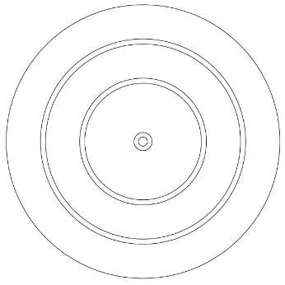
Reliable and valid Reliable but not valid Valid but not reliable Not reliable or valid

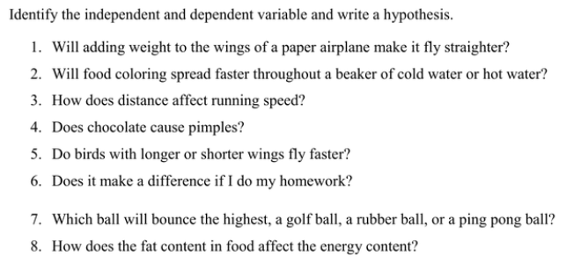
For each of the above, decide what kind of graph you would use. Write a title for a graph as well.
Question | Hypothesis | Type of graph | Title for graph
1
2
3
4

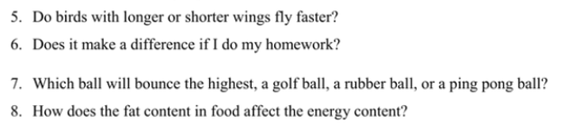
Question | Hypothesis | Type of graph | Title for graph
5
6
7
8

